**General Comments**

1. The arrangement and layout of fields should be similar among contract / equipment / staff reminder modules as far as possible.
2. For each reminder module, the arrangement and layout of fields should be similar among add, update, and view pages
3. Please group relevant information together
4. Whenever user creates / edit / delete a reminder, when he submits the changes, system needs to prompt a popup to let user confirm his action. E.g. “Are you sure to save the changes?”
5. Whenever a reminder is created / updated / deleted, system needs to display a confirmation message. E.g. “This reminder is updated successfully”, or “This reminder is not updated successfully due to system error”

**Equipment Reminder**

Add Reminder Page

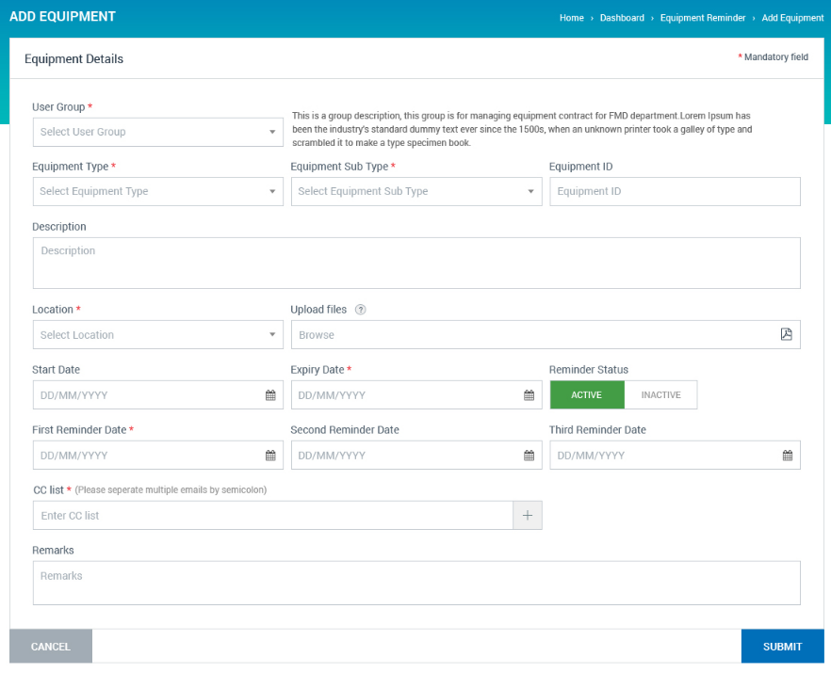

1. Move “Location” field below User Group
2. “Equipment Type” dropdown list will be filtered by selected “Location”. “Equipment Sub Type” dropdown list will be filtered by selected “Equipment Type”.
3. Rename “Start Date” to “Date Issued”
4. CC List is an optional field

Reminder List

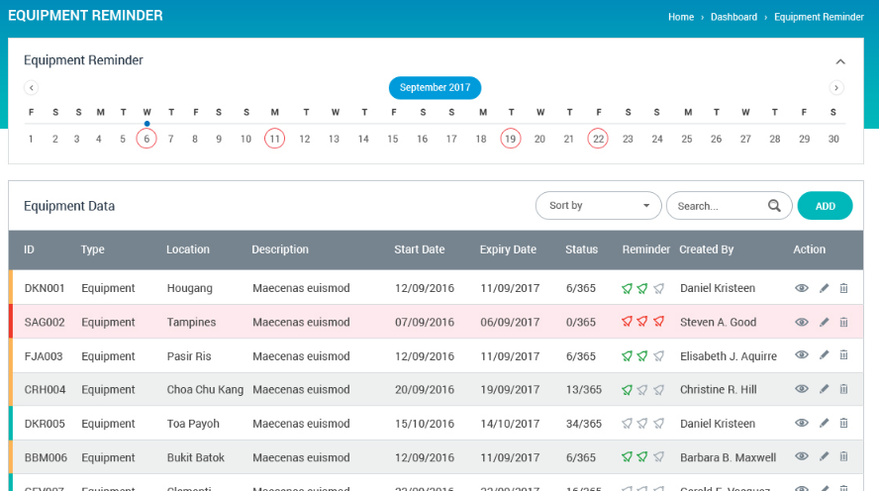

1. Please display “xx Equipment Expired” , “xx Equipment Expiring This Month” , ”xx Equipment Expiring Next Month” summary boxes below calendar. App will list relevant reminders when user clicks a summary box.

(* If current date is 29 Oct, This Month will be October, Next Month will be November)

1. Please group equipment reminders by location (location will be tugs (e.g. TG25 (Apex)), TS Store, TS Launch Workshop, etc...)
2. Fields in reminder list: Location (Group), User Group, Equipment Type, Equipment Sub Type, Equipment ID, Equipment Description, Expiry Date, Status (Active / Inactive), Action

(If Equipment Description is too long to be fully displayed in the table cell, only partial description will be displayed. Full content will be displayed in a tooltip whenever user mouse over description field.)

1. Provide “Download” function

Renew Function

1. Similar to that of contract reminder module, a renew function is required for an existing equipment to be renewed easily. After clicking renew button, system will direct user to new reminder page, with all relevant information copied from the original reminder. After renew is done, system will ask user whether he wants to inactivate the original reminder.

(* When an equipment is expired, user can either directly change the expiry date of the reminder, or use the renew function to create a new reminder)

**Staff Reminder**

Add Reminder Page

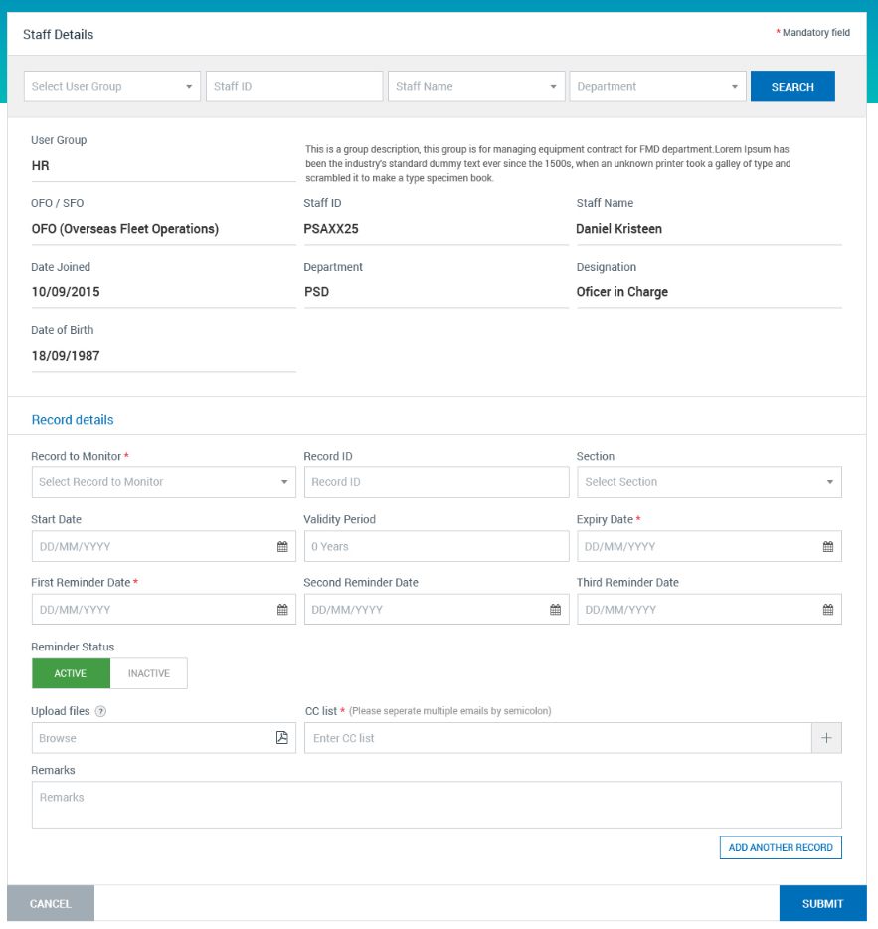

1. Move “Section” to Staff Particulars sections
2. Rename “Staff ID” to “Empl No. / NRIC”
3. Rename “Record ID” to “Reference No.”
4. “Validity Period” is a derived field showing difference between “Start Date” and “Expiry Date” (if both “Start Date” and “Expiry Date” exist).
5. CC List is an optional field
6. Search User Group and Staff Details:

* Remove the Search Section on the top of “Add Staff Record” page
* Change “User Group” to a dropdown field, user can directly select user group here.
* Change “Staff ID” and “Staff Name” to “search as you type” fields. Upon selecting Staff ID / Staff Name, staff details will be auto populated.

E.g.

- “Harry Lim (S00012)” will be shown in Staff ID dropdown list if user keys in “S0000”, “0000”, “000012”, etc. in Staff ID field. Upon selecting “Harry Lim (S00012)”, staff particulars will be auto populated

- “Harry Lim (S00012)” will be shown in Staff Name dropdown list if user keys in “Harry”, “Lim”, “arr”, etc. in Staff Name field. Upon selecting “Harry Lim (S00012)”, staff particulars will be auto populated

Reminder List

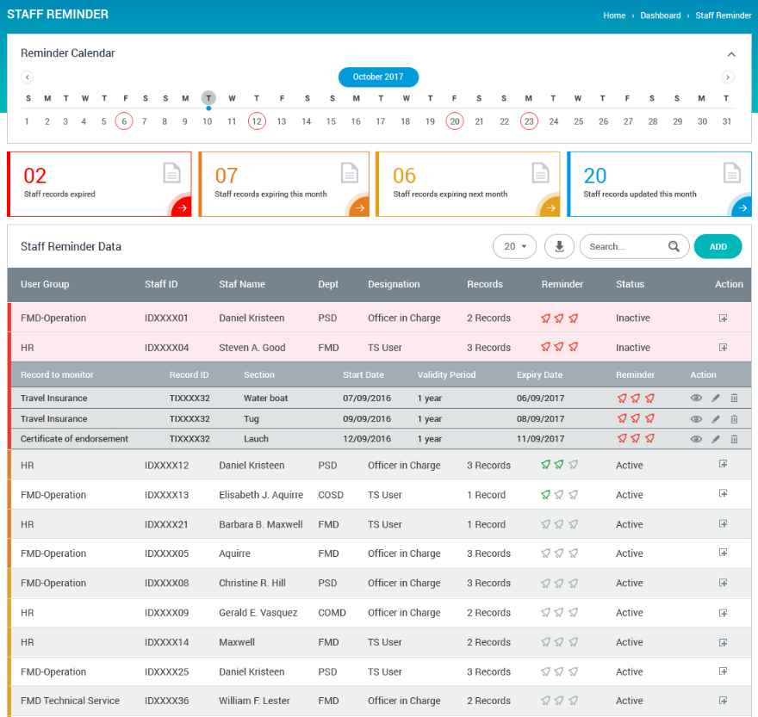

1. Please display “xx Staff Records Expired” , “xx Staff Records Expiring This Month” , ”xx Staff Records Expiring Next Month” summary box below calendar. App will list relevant reminders when user clicks a summary box.